TILLMAN COUNTY EXCISE BOARD

NOTICE & AGENDA

REGULAR MEETING

PLACE: TILLMAN COUNTY COMMISSIONERS’ OFFICE
TILLMAN COUNTY COURTHOUSE

DATE: January 29, 2016

TIME: 8:00 A.M.

NOTE: AGENDA BECOMES FINAL 24 HOURS BEFORE MEETING DATE AND TIME

PERSON FILING NOTICE: ALAN BOYD, CHAIRMAN OF THE BOARD

AGENDA:

READING AND APPROVAL OF MINUTES
CITIZENS TO BE HEARD
NEW BUSINESS
TRANSFER OF APPROPRIATIONS

Discussion and possible action to approve Cash Fund Estimates of Needs and Requests for Appropriations

Filed in the County Clerk’s office January 27. 2016

_________________________________________
Cacy Caldwell, County Clerk
TILLMAN COUNTY EXCISE BOARD

NOTICE & AGENDA

REGULAR MEETING

PLACE: TILLMAN COUNTY COMMISSIONERS’ OFFICE
TILLMAN COUNTY COURTHOUSE

DATE: December 31, 2015

TIME: 8:00 A.M.

NOTE: AGENDA BECOMES FINAL 24 HOURS BEFORE MEETING DATE AND TIME

PERSON FILING NOTICE: ALAN BOYD, CHAIRMAN OF THE BOARD

AGENDA:

READING AND APPROVAL OF MINUTES
CITIZENS TO BE HEARD
NEW BUSINESS
TRANSFER OF APPROPRIATIONS

Discussion and possible action to approve Cash Fund Estimates of Needs and Requests for Appropriations

Filed in the County Clerk’s office December 29, 2015

_________________________________________
Cacy Caldwell, County Clerk
TILLMAN COUNTY EXCISE BOARD

NOTICE & AGENDA

REGULAR MEETING

PLACE: TILLMAN COUNTY COMMISSIONERS’ OFFICE
TILLMAN COUNTY COURTHOUSE

DATE: November 30, 2015

TIME: 8:00 A.M.

NOTE: AGENDA BECOMES FINAL 24 HOURS BEFORE MEETING DATE AND TIME

PERSON FILING NOTICE: ALAN BOYD, CHAIRMAN OF THE BOARD

AGENDA:

READING AND APPROVAL OF MINUTES
CITIZENS TO BE HEARD
NEW BUSINESS
TRANSFER OF APPROPRIATIONS

Discussion and possible action to approve 2016 Schedule of Regular Meetings, Excise Board

Discussion and possible action to approve 2016 Schedule of Regular Meetings, Equalization Board

Discussion and possible action to approve Cash Fund Estimates of Needs and Requests for Appropriations

Filed in the County Clerk’s office November 23, 2015

_________________________________________
Cacy Caldwell, County Clerk
TILLMAN COUNTY EXCISE BOARD
NOTICE & AGENDA
REGULAR MEETING

PLACE: TILLMAN COUNTY COMMISSIONERS' OFFICE
TILLMAN COUNTY COURTHOUSE
DATE: October 30, 2015
TIME: 8:00 A.M.
NOTE: AGENDA BECOMES FINAL 24 HOURS BEFORE MEETING DATE AND TIME
PERSON FILING NOTICE: ALAN BOYD, CHAIRMAN OF THE BOARD
AGENDA:
READING AND APPROVAL OF MINUTES
CITIZENS TO BE HEARD
NEW BUSINESS
TRANSFER OF APPROPRIATIONS
Discussion and possible action to approve Cash Fund Estimates of Needs and Requests for Appropriations
Filed in the County Clerk's office October 28, 2015
_________________________________________
Cacy Caldwell, County Clerk

TILLMAN COUNTY EXCISE BOARD

NOTICE & AGENDA

REGULAR MEETING

PLACE: TILLMAN COUNTY COMMISSIONERS’ OFFICE
TILLMAN COUNTY COURTHOUSE

DATE: September 30, 2015

TIME: 8:00 A.M.

NOTE: AGENDA BECOMES FINAL 24 HOURS BEFORE MEETING DATE AND TIME

PERSON FILING NOTICE: ALAN BOYD, CHAIRMAN OF THE BOARD

AGENDA:

READING AND APPROVAL OF MINUTES
CITIZENS TO BE HEARD
NEW BUSINESS
TRANSFER OF APPROPRIATIONS

Discussion and possible action to approve Tillman County General Government Estimate of Needs, FY 2015-2016

Discussion and possible action to approve Tillman County Health Department Estimate of Needs, FY 2015-2016

Discussion and possible action to approve Tillman County EMS Estimate of Needs, FY 2015-2016

Discussion and possible action to approve Frederick Public Schools, ISD #158, Estimate of Needs, FY 2015-2016

Discussion and possible action to approve Grandfield Public Schools, ISD #249, Estimate of Needs, FY 2015-2016

Discussion and possible action to approve Tipton Public Schools, ISD #8, Estimate of Needs, FY 2015-2016

Discussion and possible action to approve Davidson Public Schools, ISD #9, Estimate of Needs, FY 2015-2016

Discussion and possible action to approve City of Grandfield Estimate of Needs, FY 2015-2016

Discussion and possible action to approve Cash Fund Estimates of Needs and Requests for Appropriations

Filed in the County Clerk’s office September 28, 2015

_________________________________________
Cacy Caldwell, County Clerk
TILLMAN COUNTY EXCISE BOARD

NOTICE & AGENDA

REGULAR MEETING

PLACE: TILLMAN COUNTY COMMISSIONERS’ OFFICE
TILLMAN COUNTY COURTHOUSE

DATE: August 31, 2015

TIME: 8:00 A.M.

NOTE: AGENDA BECOMES FINAL 24 HOURS BEFORE MEETING DATE AND TIME

PERSON FILING NOTICE: ALAN BOYD, CHAIRMAN OF THE BOARD

AGENDA:

READING AND APPROVAL OF MINUTES
CITIZENS TO BE HEARD
NEW BUSINESS
TRANSFER OF APPROPRIATIONS

Discussion and possible action to approve and submit to budget maker the Tillman County FY 2015 Budget

Discussion and possible action to approve Cash Fund Estimates of Needs and Requests for Appropriations

Filed in the County Clerk’s office August 27, 2015

_________________________________________
Cacy Caldwell, County Clerk
TILLMAN COUNTY EXCISE BOARD

NOTICE & AGENDA

REGULAR MEETING

PLACE: TILLMAN COUNTY COMMISSIONERS’ OFFICE
TILLMAN COUNTY COURTHOUSE

DATE: July 31, 2015

TIME: 8:00 A.M.

NOTE: AGENDA BECOMES FINAL 24 HOURS BEFORE MEETING DATE AND TIME

PERSON FILING NOTICE: ALAN BOYD, CHAIRMAN OF THE BOARD

AGENDA:

READING AND APPROVAL OF MINUTES
CITIZENS TO BE HEARD
NEW BUSINESS
TRANSFER OF APPROPRIATIONS

Discussion and possible action to approve Temporary Appropriations, Davidson Public School District #9, FY 2016

Discussion and possible action to approve FY 14-15 Cash Fund Carry-Over Appropriations

Discussion and possible action to approve Cash Fund Estimates of Needs and Requests for Appropriations

Filed in the County Clerk’s office July 29, 2015

_________________________________________
Cacy Caldwell, County Clerk
TILLMAN COUNTY EXCISE BOARD

NOTICE & AGENDA

REGULAR MEETING

PLACE: TILLMAN COUNTY COMMISSIONERS’ OFFICE
TILLMAN COUNTY COURTHOUSE

DATE: June 30, 2015

TIME: 8:00 A.M.

NOTE: AGENDA BECOMES FINAL 24 HOURS BEFORE MEETING DATE AND TIME

PERSON FILING NOTICE: KAY ATKINS, CHAIRMAN OF THE BOARD

AGENDA:

READING AND APPROVAL OF MINUTES
CITIZENS TO BE HEARD
NEW BUSINESS
TRANSFER OF APPROPRIATIONS

Discussion and possible action to elect Chairman, effective July 1, 2015

Discussion and possible action to elect Vice-Chairman, effective July 1, 2015

Discussion and possible action to approve Cash Fund Estimates of Needs and Requests for Appropriations

Filed in the County Clerk’s office June 26, 2015

_________________________________________
Cacy Caldwell, County Clerk
TILLMAN COUNTY EXCISE BOARD

NOTICE & AGENDA

REGULAR MEETING

PLACE: TILLMAN COUNTY COMMISSIONERS’ OFFICE
TILLMAN COUNTY COURTHOUSE

DATE: May 29, 2015

TIME: 8:00 A.M.

NOTE: AGENDA BECOMES FINAL 24 HOURS BEFORE MEETING DATE AND TIME

PERSON FILING NOTICE: KAY ATKINS, CHAIRMAN OF THE BOARD

AGENDA:

READING AND APPROVAL OF MINUTES
CITIZENS TO BE HEARD
NEW BUSINESS
TRANSFER OF APPROPRIATIONS

Discussion and possible action to approve Cash Fund Estimates of Needs and Requests for Appropriations

Filed in the County Clerk’s office May 27, 2015

_________________________________________
Cacy Caldwell, County Clerk
TILLMAN COUNTY EXCISE BOARD

NOTICE & AGENDA

REGULAR MEETING

PLACE: TILLMAN COUNTY COMMISSIONERS’ OFFICE
TILLMAN COUNTY COURTHOUSE

DATE: March 31, 2015

TIME: 8:00 A.M.

NOTE: AGENDA BECOMES FINAL 24 HOURS BEFORE MEETING DATE AND TIME

PERSON FILING NOTICE: KAY ATKINS, CHAIRMAN OF THE BOARD

AGENDA:

READING AND APPROVAL OF MINUTES
CITIZENS TO BE HEARD
NEW BUSINESS
TRANSFER OF APPROPRIATIONS

Discussion and possible action to approve Cash Fund Estimates of Needs and Requests for Appropriations

Filed in the County Clerk’s office March 27, 2015

_________________________________________
Cacy Caldwell, County Clerk
TILLMAN COUNTY EXCISE BOARD

NOTICE & AGENDA

REGULAR MEETING

PLACE: TILLMAN COUNTY COMMISSIONERS’ OFFICE
TILLMAN COUNTY COURTHOUSE

DATE: March 31, 2014

TIME: 8:00 A.M.

NOTE: AGENDA BECOMES FINAL 24 HOURS BEFORE MEETING DATE AND TIME

PERSON FILING NOTICE: TERRAL TATUM, CHAIRMAN OF THE BOARD

AGENDA:

READING AND APPROVAL OF MINUTES, REGULAR MEETING
CITIZENS TO BE HEARD
NEW BUSINESS
TRANSFER OF APPROPRIATIONS

Discussion and possible action to approve Cash Fund Estimates of Needs and Requests for Appropriations as listed below submitted by County Treasurer

Filed in the County Clerk’s office March 27, 2014

_________________________________________
Cacy Caldwell, County ClerkTILLMAN COUNTY EXCISE BOARD

NOTICE & AGENDA

REGULAR MEETING

PLACE: TILLMAN COUNTY COMMISSIONERS’ OFFICE
TILLMAN COUNTY COURTHOUSE

DATE: February 28, 2014

TIME: 8:00 A.M.

NOTE: AGENDA BECOMES FINAL 24 HOURS BEFORE MEETING DATE AND TIME

PERSON FILING NOTICE: TERRAL TATUM, CHAIRMAN OF THE BOARD

AGENDA:

READING AND APPROVAL OF MINUTES, REGULAR MEETING
CITIZENS TO BE HEARD
NEW BUSINESS
TRANSFER OF APPROPRIATIONS

Discussion and possible action to approve Cash Fund Estimates of Needs and Requests for Appropriations as listed below submitted by County Treasurer

Filed in the County Clerk’s office February 26, 2014

_________________________________________
Cacy Caldwell, County Clerk
TILLMAN COUNTY EXCISE BOARD

NOTICE & AGENDA

REGULAR MEETING

PLACE: TILLMAN COUNTY COMMISSIONERS’ OFFICE
TILLMAN COUNTY COURTHOUSE

DATE: December 31, 2013

TIME: 8:00 A.M.

NOTE: AGENDA BECOMES FINAL 24 HOURS BEFORE MEETING DATE AND TIME

PERSON FILING NOTICE: TERRAL TATUM, CHAIRMAN OF THE BOARD

AGENDA:

READING AND APPROVAL OF MINUTES, REGULAR MEETING
CITIZENS TO BE HEARD
NEW BUSINESS
TRANSFER OF APPROPRIATIONS

Discussion and possible action to approve Cash Fund Estimates of Needs and Requests for Appropriations as listed below submitted by County Treasurer

Filed in the County Clerk’s office December 23, 2013

_________________________________________
Cacy Caldwell, County Clerk
TILLMAN COUNTY EXCISE BOARD

NOTICE & AGENDA

REGULAR MEETING

PLACE: TILLMAN COUNTY COMMISSIONERS’ OFFICE
TILLMAN COUNTY COURTHOUSE

DATE: November 26, 2013

TIME: 8:00 A.M.

NOTE: AGENDA BECOMES FINAL 24 HOURS BEFORE MEETING DATE AND TIME

PERSON FILING NOTICE: TERRAL TATUM, CHAIRMAN OF THE BOARD

AGENDA:

READING AND APPROVAL OF MINUTES, REGULAR MEETING
CITIZENS TO BE HEARD
NEW BUSINESS
TRANSFER OF APPROPRIATIONS

Discussion and possible action to approve 2014 Schedule of Regular Meetings

Discussion and possible action to approve Cash Fund Estimate of Needs and Request for Appropriations as listed below submitted by County Treasurer

Filed in the County Clerk’s office November 21, 2013

_________________________________________
Cacy Caldwell, County Clerk
TILLMAN COUNTY EXCISE BOARD
AGENDA

PLACE: TILLMAN COUNTY CLERK’S OFFICE
TILLMAN COUNTY COURTHOUSE

DATE: October 31, 2013

TIME: 8:00 A.M.

NOTE: AGENDA BECOMES FINAL 24 HOURS BEFORE MEETING DATE AND TIME

PERSON FILING NOTICE: TERRAL TATUM, CHAIRMAN OF THE BOARD

AGENDA:

READING AND APPROVAL OF MINUTES, REGULAR MEETING
CITIZENS TO BE HEARD
NEW BUSINESS
TRANSFER OF APPROPRIATIONS

Discussion and possible action to approve Cash Fund Estimate of Needs and Request for Appropriations as listed below submitted by County Treasurer

Filed in the County Clerk’s office October 30, 2013

_________________________________________
Cacy Caldwell, County ClerkTILLMAN COUNTY EXCISE BOARD
AGENDA

PLACE: TILLMAN COUNTY CLERK’S OFFICE
TILLMAN COUNTY COURTHOUSE

DATE: September 30, 2013

TIME: 8:00 A.M.

NOTE: AGENDA BECOMES FINAL 24 HOURS BEFORE MEETING DATE AND TIME

PERSON FILING NOTICE: TERRAL TATUM, CHAIRMAN OF THE BOARD

AGENDA:

READING AND APPROVAL OF MINUTES, REGULAR MEETING
CITIZENS TO BE HEARD
NEW BUSINESS
TRANSFER OF APPROPRIATIONS

Discussion and possible action to approve final Tillman County General Government Estimate of Needs, FY 2013-2014

Discussion and possible action to approve Frederick Public Schools, ISD #158, Estimate of Needs, FY 2013-2014

Discussion and possible action to approve Grandfield Public Schools, ISD #249, Estimate of Needs, FY 2012-2103

Discussion and possible action to approve Tipton Public Schools, ISD #8, Estimate of Needs, FY 2013-2014

Discussion and possible action to approve Davidson Public Schools, ISD #9, Estimate of Needs, FY 2013-2014

Discussion and possible action to approve Tillman County Health Department Estimate of Needs, FY 2013-2014

Discussion and possible action to approve Tillman County Emergency Management Service Estimate of Needs, FY 2013-2014

Discussion and possible action to approve City of Grandfield Estimate of Needs, FY 2013-2014

Discussion and possible action to approve Cash Fund Estimate of Needs and Request for Appropriations as listed below submitted by County Treasurer

Filed in the County Clerk’s office September 26, 2013

_________________________________________
Cacy Caldwell, County Clerk
TILLMAN COUNTY EXCISE BOARD
AGENDA

PLACE: TILLMAN COUNTY CLERK’S OFFICE
TILLMAN COUNTY COURTHOUSE

DATE: August 30, 2013

TIME: 8:00 A.M.

NOTE: AGENDA BECOMES FINAL 24 HOURS BEFORE MEETING DATE AND TIME

PERSON FILING NOTICE: TERRAL TATUM, CHAIRMAN OF THE BOARD

AGENDA:

READING AND APPROVAL OF MINUTES, REGULAR MEETING
READING AND APPROVAL OF MINUTES, SPECIAL MEETING
CITIZENS TO BE HEARD
NEW BUSINESS
TRANSFER OF APPROPRIATIONS

Discussion and possible action to approve Amended Temporary Appropriations, Tipton Public School District #8, FY 2014

Discussion and possible action to approve and submit to budget maker the Tillman County FY 2014 Budget

Discussion and possible action to approve Cash Fund Estimates of Needs and Requests for Appropriations as submitted by County Treasurer

Filed in the County Clerk’s office August 28, 2013

_________________________________________
Cacy Caldwell, County ClerkAMENDED
TILLMAN COUNTY EXCISE BOARD
AGENDA

PLACE: TILLMAN COUNTY CLERK’S OFFICE
TILLMAN COUNTY COURTHOUSE

DATE: July 31, 2013

TIME: 8:00 A.M.

NOTE: AGENDA BECOMES FINAL 24 HOURS BEFORE MEETING DATE AND TIME

PERSON FILING NOTICE: TERRAL TATUM, CHAIRMAN OF THE BOARD

AGENDA:

READING AND APPROVAL OF MINUTES, REGULAR MEETING
READING AND APPROVAL OF MINUTES, SPECIAL MEETING
CITIZENS TO BE HEARD
NEW BUSINESS
TRANSFER OF APPROPRIATIONS

Discussion and possible action to approve Temporary Appropriations, Davidson Public School District #9, FY 2014

Discussion and possible action to approve Amended Temporary Appropriations, Grandfield Public School District #249, FY 2014

Discussion and possible action to approve Cash Fund Estimates of Needs and Requests for Appropriations

Filed in the County Clerk’s office July 29, 2013

_________________________________________
Cacy Caldwell, County Clerk
TILLMAN COUNTY EXCISE BOARD
AGENDA
SPECIAL MEETING

NOTICE OF SPECIAL MEETING

PLACE: TILLMAN COUNTY CLERK’S OFFICE, FREDERICK, OKLAHOMA

DATE: JULY 19, 2013

TIME: 8:00 A.M.

NOTE: AGENDA BECOMES FINAL 48 HOURS BEFORE MEETING DATE AND TIME

AGENDA:

CITIZENS TO BE HEARD

NEW BUSINESS

Public hearing to allow any taxpayer to appear and be heard for or against any part of the statements of estimated needs, FY 2014

Filed in the County Clerk’s office July 15, 2012

_____________________________________
Cacy Caldwell, County Clerk

TILLMAN COUNTY EXCISE BOARD
AGENDA

PLACE: TILLMAN COUNTY CLERK’S OFFICE
TILLMAN COUNTY COURTHOUSE

DATE: July 1, 2013

TIME: 8:00 A.M.

NOTE: AGENDA BECOMES FINAL 24 HOURS BEFORE MEETING DATE AND TIME

PERSON FILING NOTICE: TERRAL TATUM, CHAIRMAN OF THE BOARD

AGENDA:

READING AND APPROVAL OF MINUTES
CITIZENS TO BE HEARD
NEW BUSINESS
TRANSFER OF APPROPRIATIONS

Discussion and possible action to hold public hearing to allow any taxpayer to be heard for or against any part of the statements of estimated needs, FY 2014, in accordance with 68 O.S. § 3012

Discussion and possible action to approve Temporary Appropriations, Grandfield Public School District #249, FY 2014

Discussion and possible action to approve Temporary Appropriations, Tipton Public School District #8, FY 2014

Discussion and possible action to approve 1.75mil levy as approved by the voters, as well as all surplus funds for the operation of the Tillman County Health Department, FY 2014

Discussion and possible action to approve Temporary Appropriations, Health Department, FY 2014

Discussion and possible action to approve Temporary Appropriations, Tillman County, FY 2014

Filed in the County Clerk’s office June 26, 2013

_________________________________________
Cacy Caldwell, County Clerk
TILLMAN COUNTY EXCISE BOARD
AGENDA

PLACE: TILLMAN COUNTY CLERK’S OFFICE
TILLMAN COUNTY COURTHOUSE

DATE: June 28, 2013

TIME: 8:00 A.M.

NOTE: AGENDA BECOMES FINAL 24 HOURS BEFORE MEETING DATE AND TIME

PERSON FILING NOTICE: TERRAL TATUM, CHAIRMAN OF THE BOARD

AGENDA:

READING AND APPROVAL OF MINUTES
CITIZENS TO BE HEARD
NEW BUSINESS
TRANSFER OF APPROPRIATIONS

Discussion and possible action to elect Tillman County Board Chairman, effective July 1, 2013

Discussion and possible action to elect Tillman County Board Vice-Chairman, effective July 1, 2013

Discussion and possible action to approve Cash Fund Estimate of Needs and Request for Appropriations

Filed in the County Clerk’s office June 26, 2013

_________________________________________
Cacy Caldwell, County Clerk
TILLMAN COUNTY EXCISE BOARD
AGENDA

PLACE: TILLMAN COUNTY CLERK’S OFFICE
TILLMAN COUNTY COURTHOUSE

DATE: May 31, 2013

TIME: 8:00 A.M.

NOTE: AGENDA BECOMES FINAL 24 HOURS BEFORE MEETING DATE AND TIME

PERSON FILING NOTICE: TERRAL TATUM, CHAIRMAN OF THE BOARD

AGENDA:

READING AND APPROVAL OF EXCISE BOARD MINUTES
CITIZENS TO BE HEARD
NEW BUSINESS
TRANSFER OF APPROPRIATIONS

Discussion and possible action to approve temporary appropriations for Tipton Public Schools for FY 2013-2014

Discussion and possible action to approve Estimate of Needs for Tillman County
Health Department for FY 2013-2014

Filed in the County Clerk’s office May 17, 2013

_________________________________________
Cacy Caldwell, County Clerk
TILLMAN COUNTY EXCISE BOARD
AGENDA

PLACE: TILLMAN COUNTY CLERK’S OFFICE
TILLMAN COUNTY COURTHOUSE

DATE: April 30, 2013

TIME: 8:00 A.M.

NOTE: AGENDA BECOMES FINAL 24 HOURS BEFORE MEETING DATE AND TIME

PERSON FILING NOTICE: TERRAL TATUM, CHAIRMAN OF THE BOARD

AGENDA:

READING AND APPROVAL OF EXCISE BOARD MINUTES
CITIZENS TO BE HEARD
NEW BUSINESS
TRANSFER OF APPROPRIATIONS

Discussion and possible action to approve Cash Fund Estimate of Needs and Request for Appropriations

Filed in the County Clerk’s office April 29, 2013

_________________________________________
Cacy Caldwell, County Clerk

TILLMAN COUNTY EXCISE BOARD
AGENDA

PLACE: TILLMAN COUNTY CLERK’S OFFICE
TILLMAN COUNTY COURTHOUSE

DATE: March 28, 2013

TIME: 8:00 A.M.

NOTE: AGENDA BECOMES FINAL 24 HOURS BEFORE MEETING DATE AND TIME

PERSON FILING NOTICE: TERRAL TATUM, CHAIRMAN OF THE BOARD

AGENDA:

READING AND APPROVAL OF EXCISE BOARD MINUTES
CITIZENS TO BE HEARD
NEW BUSINESS
TRANSFER OF APPROPRIATIONS

Discussion and possible action to approve Cash Fund Estimate of Needs and Request for Appropriations

Filed in the County Clerk’s office March 26, 2013

_________________________________________
Cacy Caldwell, County Clerk
TILLMAN COUNTY EXCISE BOARD
AGENDA

PLACE: TILLMAN COUNTY CLERK’S OFFICE
TILLMAN COUNTY COURTHOUSE

DATE: FEBRUARY 28, 2013

TIME: 8:00 A.M.

NOTE: AGENDA BECOMES FINAL 24 HOURS BEFORE MEETING DATE AND TIME

PERSON FILING NOTICE: TERRAL TATUM, CHAIRMAN OF THE BOARD

AGENDA:

READING AND APPROVAL OF EXCISE BOARD MINUTES
CITIZENS TO BE HEARD
NEW BUSINESS
TRANSFER OF APPROPRIATIONS

Discussion and possible action to approve Cash Fund Estimate of Needs and Request for Appropriations

Filed in the County Clerk’s office February 26, 2013

_________________________________________
Cacy Caldwell, County Clerk
TILLMAN COUNTY EXCISE BOARD
AGENDA

PLACE: TILLMAN COUNTY CLERK’S OFFICE
TILLMAN COUNTY COURTHOUSE

DATE: JANUARY 31, 2012

TIME: 8:00 A.M.

NOTE: AGENDA BECOMES FINAL 24 HOURS BEFORE MEETING DATE AND TIME

PERSON FILING NOTICE: TERRAL TATUM, CHAIRMAN OF THE BOARD

AGENDA:

READING AND APPROVAL OF EXCISE BOARD MINUTES
CITIZENS TO BE HEARD
NEW BUSINESS
TRANSFER OF APPROPRIATIONS

Discussion and possible action to approve Cash Fund Estimate of Needs and Request for Appropriations

Filed in the County Clerk’s office January 29, 2012

_________________________________________
TILLMAN COUNTY EXCISE BOARD
AGENDA

PLACE: TILLMAN COUNTY CLERK’S OFFICE
TILLMAN COUNTY COURTHOUSE

DATE: DECEMBER 31, 2012

TIME: 8:00 A.M.

NOTE: AGENDA BECOMES FINAL 24 HOURS BEFORE MEETING DATE AND TIME

PERSON FILING NOTICE: TERRAL TATUM, CHAIRMAN OF THE BOARD

AGENDA:

READING AND APPROVAL OF EXCISE BOARD MINUTES
CITIZENS TO BE HEARD
NEW BUSINESS
TRANSFER OF APPROPRIATIONS

Discussion and possible action to approve Cash Fund Estimate of Needs and Request for Appropriations

Filed in the County Clerk’s office December 27, 2012

_________________________________________
Jerri Boyd, County Clerk
TILLMAN COUNTY EXCISE BOARD
AGENDA

PLACE: TILLMAN COUNTY CLERK’S OFFICE
TILLMAN COUNTY COURTHOUSE

DATE: NOVEMBER 30, 2012

TIME: 8:00 A.M.

NOTE: AGENDA BECOMES FINAL 24 HOURS BEFORE MEETING DATE AND TIME

PERSON FILING NOTICE: TERRAL TATUM, CHAIRMAN OF THE BOARD

AGENDA:

READING AND APPROVAL OF EXCISE BOARD MINUTES
CITIZENS TO BE HEARD
NEW BUSINESS
TRANSFER OF APPROPRIATIONS

Discussion and possible action to approve schedule of regular meetings for calendar year 2013

Discussion and possible action to approve Cash Fund Estimate of Needs and Request for Appropriations

Filed in the County Clerk’s office November 28, 2012

_________________________________________
Jerri Boyd, County Clerk
*****CORRECTED*****
TILLMAN COUNTY EXCISE BOARD
AGENDA

PLACE: TILLMAN COUNTY CLERK’S OFFICE
TILLMAN COUNTY COURTHOUSE

DATE: SEPTEMBER 28, 2012

TIME: 8:00 A.M.

NOTE: AGENDA BECOMES FINAL 24 HOURS BEFORE MEETING DATE AND TIME

PERSON FILING NOTICE: TERRAL TATUM, CHAIRMAN OF THE BOARD

AGENDA:

READING AND APPROVAL OF EXCISE BOARD MINUTES
CITIZENS TO BE HEARD
NEW BUSINESS
TRANSFER OF APPROPRIATIONS

Discussion and possible action to approve cash fund estimate of needs and request for appropriations

Discussion and possible action to approve Tillman County General Government Estimate of Needs, FY 2012-2013

Discussion and possible action to approve Frederick Public School, ISD #158, Estimate of
Needs, FY 2012-2013

Discussion and possible action to approve Grandfield Public Schools, ISD #249, Estimate of Needs, FY 2012-2013

Discussion and possible action to approve Tipton Public Schools, ISD #8, Estimate of Needs, FY 2012-2013

Discussion and possible action to approve Davidson Public Schools, ISD #9, Estimate of Needs, FY 2012-2013

Discussion and possible action to approve Tillman County Health Department Estimate of Needs, FY 2012-2013

Discussion and possible action to approve Tillman County Emergency Management Service Board Estimate of Needs, FY 2012-2013

Discussion and possible action to approve City of Grandfield Estimate of Needs, FY 2012-2013

Filed in the County Clerk’s office September 26, 2012.

_________________________________________
Jerri Boyd, County Clerk
TILLMAN COUNTY EXCISE BOARD
AGENDA

PLACE: TILLMAN COUNTY CLERK’S OFFICE
TILLMAN COUNTY COURTHOUSE

DATE: SEPTEMBER 28, 2012

TIME: 8:00 A.M.

NOTE: AGENDA BECOMES FINAL 24 HOURS BEFORE MEETING DATE AND TIME

PERSON FILING NOTICE: TERRAL TATUM, CHAIRMAN OF THE BOARD

AGENDA:

READING AND APPROVAL OF EXCISE BOARD MINUTES
CITIZENS TO BE HEARD
NEW BUSINESS
TRANSFER OF APPROPRIATIONS

Discussion and possible action to approve cash fund estimate of needs and request for appropriations

Discussion and possible action to approve Tillman County General Government Estimate of Needs, FY 2012-2013

Discussion and possible action to approve Frederick Public School, ISD #158, Estimate of
Needs, FY 2012-2013

Discussion and possible action to approve Grandfield Public Schools, ISD #249, Estimate of Needs, FY 2012-2013

Discussion and possible action to approve Tipton Public Schools, ISD #8, Estimate of Needs, FY 2012-2013

Discussion and possible action to approve Davidson Public Schools, ISD #9, Estimate of Needs, FY 2012-2013

Discussion and possible action to approve Tillman County Health Department Estimate of Needs, FY 2012-2013

Discussion and possible action to approve Tillman County Emergency Management Service Board Estimate of Needs, FY 2012-2013

Filed in the County Clerk’s office September 25, 2012.
TILLMAN COUNTY EXCISE BOARD
AGENDA

PLACE: TILLMAN COUNTY CLERK’S OFFICE
TILLMAN COUNTY COURTHOUSE

DATE: JULY 31, 2012

TIME: 8:00 A.M.

NOTE: AGENDA BECOMES FINAL 24 HOURS BEFORE MEETING DATE AND TIME

PERSON FILING NOTICE: TERAL TATUM, CHAIRMAN OF THE BOARD

AGENDA:

READING AND APPROVAL OF EXCISE BOARD MINUTES
CITIZENS TO BE HEARD
NEW BUSINESS
TRANSFER OF APPROPRIATIONS

Discussion and possible action to approve minutes of regular meeting, June 29, 2012

Discussion and possible action to approve minutes of special meeting, July 2, 2012

Discussion and possible action to approve minutes of special meeting, July 10, 2012

Discussion and possible action to approve transfer of cash account carry-over balances from FY 2011-2012

Discussion and possible action to approve appropriations and cash fund estimate of needs, July, 2012

Discussion on “Assessor’s Report to Excise Board” certified by County Assessor Linda Coleman that the values as set forth for the above Tillman County School Districts are true and correct for the year 2012 tax year as certified by the State Board of Equalization

Filed in the County Clerk’s office July 26, 2012.

_________________________________________
Jerri Boyd, County Clerk
SPECIAL MEETING

TILLMAN COUNTY EXCISE BOARD
AGENDA

PLACE: TILLMAN COUNTY CLERK’S OFFICE
TILLMAN COUNTY COURTHOUSE

DATE: Monday July 2, 2012

TIME: 8:00 A.M.

NOTE: AGENDA BECOMES FINAL 48 HOURS BEFORE MEETING DATE AND TIME

AGENDA:

CITIZENS TO BE HEARD

Discussion and possible action to elect Chairman of Board, FY 2013

Discussion and possible action to elect Vice-Chair of Board, FY 2013

Discussion and possible action to set date, time and place for public hearing to allow any taxpayer to be heard for or against any part of the statements of estimated needs, FY 2013

Filed in the County Clerk’s office June 27, 2012

_________________________________________
Jerri Boyd, County Clerk

TILLMAN COUNTY EXCISE BOARD
AGENDA

PLACE: TILLMAN COUNTY CLERK’S OFFICE
TILLMAN COUNTY COURTHOUSE

DATE: JUNE 29, 2012

TIME: 8:00 A.M.

NOTE: AGENDA BECOMES FINAL 24 HOURS BEFORE MEETING DATE AND TIME

PERSON FILING NOTICE: ALAN BOYD, CHAIRMAN OF THE BOARD

AGENDA:

READING AND APPROVAL OF EXCISE BOARD MINUTES
CITIZENS TO BE HEARD
NEW BUSINESS
TRANSFER OF APPROPRIATIONS

Discussion and possible action to approve appropriations and cash fund estimate of needs

Discussion and possible action for approval of temporary appropriations Tillman County, FY 2013

Filed in the County Clerk’s office June 27, 2012.

_________________________________________
Jerri Boyd, County Clerk

TILLMAN COUNTY EXCISE BOARD
AGENDA

PLACE: TILLMAN COUNTY CLERK’S OFFICE
TILLMAN COUNTY COURTHOUSE

DATE: MAY 31, 2012

TIME: 8:00 A.M.

NOTE: AGENDA BECOMES FINAL 24 HOURS BEFORE MEETING DATE AND TIME

PERSON FILING NOTICE: ALAN BOYD, CHAIRMAN OF THE BOARD

AGENDA:

READING AND APPROVAL OF EXCISE BOARD MINUTES
CITIZENS TO BE HEARD
NEW BUSINESS
TRANSFER OF APPROPRIATIONS

Discussion and possible action to approve appropriations and cash fund estimate of needs

Discussion and possible action to approve Tillman County Health Department request for 1.75mill levy as approved by the voters, as well as all surplus funds for the operation of the County Health Department, FY 2013

Discussion and possible action for approval of temporary appropriations ISD#8, Tipton, FY 2013

Filed in the County Clerk’s office May 29, 2012.

_________________________________________
Jerri Boyd, County Clerk
TILLMAN COUNTY EXCISE BOARD
AGENDA

PLACE: TILLMAN COUNTY CLERK’S OFFICE
TILLMAN COUNTY COURTHOUSE

DATE: APRIL 30, 2012

TIME: 8:00 A.M.

NOTE: AGENDA BECOMES FINAL 24 HOURS BEFORE MEETING DATE AND TIME

PERSON FILING NOTICE: ALAN BOYD, CHAIRMAN OF THE BOARD

AGENDA:

READING AND APPROVAL OF EXCISE BOARD MINUTES
CITIZENS TO BE HEARD
NEW BUSINESS
TRANSFER OF APPROPRIATIONS

Discussion and possible action to approve appropriations and cash fund estimate of needs

Filed in the County Clerk’s office April 26, 2012.

_________________________________________
Jerri Boyd, County Clerk

TILLMAN COUNTY EXCISE BOARD
AGENDA

PLACE: TILLMAN COUNTY CLERK’S OFFICE
TILLMAN COUNTY COURTHOUSE

DATE: MARCH 30, 2012

TIME: 8:00 A.M.

NOTE: AGENDA BECOMES FINAL 24 HOURS BEFORE MEETING DATE AND TIME

PERSON FILING NOTICE: ALAN BOYD, CHAIRMAN OF THE BOARD

AGENDA:

READING AND APPROVAL OF EXCISE BOARD MINUTES
CITIZENS TO BE HEARD
NEW BUSINESS
TRANSFER OF APPROPRIATIONS

Discussion and possible action to approve appropriations and cash fund estimate of needs

Filed in the County Clerk’s office March 28, 2012.

_________________________________________
Jerri Boyd, County Clerk
TILLMAN COUNTY EXCISE BOARD
AGENDA

PLACE: TILLMAN COUNTY CLERK’S OFFICE
TILLMAN COUNTY COURTHOUSE

DATE: FEBRUARY 29, 2012

TIME: 8:00 A.M.

NOTE: AGENDA BECOMES FINAL 24 HOURS BEFORE MEETING DATE AND TIME

PERSON FILING NOTICE: ALAN BOYD, CHAIRMAN OF THE BOARD

AGENDA:

READING AND APPROVAL OF EXCISE BOARD MINUTES
CITIZENS TO BE HEARD
NEW BUSINESS
TRANSFER OF APPROPRIATIONS

Discussion and possible action to approve appropriations and cash fund estimate of needs

Filed in the County Clerk’s office February 24, 2012.

_________________________________________
Jerri Boyd, County Clerk

TILLMAN COUNTY EXCISE BOARD
AGENDA

PLACE: TILLMAN COUNTY CLERK’S OFFICE
TILLMAN COUNTY COURTHOUSE

DATE: JANUARY 31, 2012

TIME: 8:00 A.M.

NOTE: AGENDA BECOMES FINAL 24 HOURS BEFORE MEETING DATE AND TIME

PERSON FILING NOTICE: ALAN BOYD, CHAIRMAN OF THE BOARD

AGENDA:

READING AND APPROVAL OF EXCISE BOARD MINUTES
CITIZENS TO BE HEARD
NEW BUSINESS
TRANSFER OF APPROPRIATIONS

Discussion and possible action to approve appropriations and cash fund estimate of needs

Filed in the County Clerk’s office January 26, 2012.

_________________________________________
Jerri Boyd, County Clerk

TILLMAN COUNTY EXCISE BOARD
AGENDA

PLACE: TILLMAN COUNTY CLERK’S OFFICE
TILLMAN COUNTY COURTHOUSE

DATE: DECEMBER 30, 2011

TIME: 8:00 A.M.

NOTE: AGENDA BECOMES FINAL 24 HOURS BEFORE MEETING DATE AND TIME

PERSON FILING NOTICE: ALAN BOYD, CHAIRMAN OF THE BOARD

AGENDA:

READING AND APPROVAL OF EXCISE BOARD MINUTES
CITIZENS TO BE HEARD
NEW BUSINESS
TRANSFER OF APPROPRIATIONS

Discussion and possible action to approve appropriations and cash fund estimate of needs

Filed in the County Clerk’s office December 22, 2011.

_________________________________________
Jerri Boyd, County Clerk

SPECIAL MEETING

TILLMAN COUNTY EXCISE BOARD
AGENDA

PLACE: TILLMAN COUNTY CLERK’S OFFICE
TILLMAN COUNTY COURTHOUSE

DATE: October 21, 2011

TIME: 1:00 P.M.

NOTE: AGENDA BECOMES FINAL 48 HOURS BEFORE MEETING DATE AND TIME

AGENDA:

CITIZENS TO BE HEARD

Discussion and possible action to approve Tillman County Health Department budget, FY 2011-2012

Filed in the County Clerk’s office October 18, 2011

_________________________________________
Jerri Boyd, County Clerk

NOTICE OF CHANGE IN MEETING DATE,
TIME AND/OR PLACE

In accordance with the Oklahoma Open Meeting Act (Title 25 of the Oklahoma Statutes, Section 301 and following as amended, the Tillman County Excise Board, a governmental subdivision public body of the State of Oklahoma, with office located at Tillman County Courthouse, 201 N. Main, Frederick, OK files this Notice of Change of Meeting, Date, Time and/or Place with the County Clerk of Tillman County, Oklahoma.

Original Meeting Date, Time and Place: Monday, October 31, 2011, 9:00 A.M.
_____________________________________________________________________________________________

This is a: (Check One)

_____ Special Meeting _____ Emergency Meeting

_____ Canceled Meeting _____ Continued or Reconvened

X Rescheduled Regular Meeting

_____________________________________________________________________________________________

New Meeting Date, Time and Place: Monday, October 31, 2011, 8:00 A.M.
_____________________________________________________________________________________________

Remarks:

NAME OF PERSON REPORTING:

NAME: Jerri Boyd

TITLE: Tillman County Clerk

DATE: October 14, 2011

SIGNATURE:______________________________________________________________

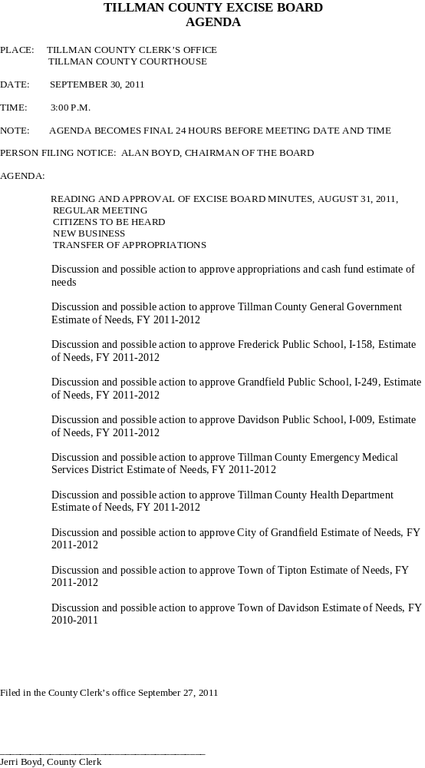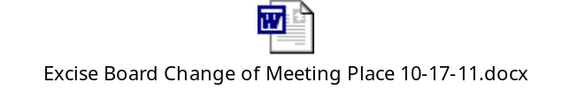TILLMAN COUNTY EXCISE BOARD
AGENDA

PLACE: TILLMAN COUNTY CLERK’S OFFICE
TILLMAN COUNTY COURTHOUSE

DATE: AUGUST 31, 2011

TIME: 9:00 A.M.

NOTE: AGENDA BECOMES FINAL 24 HOURS BEFORE MEETING DATE AND TIME

AGENDA:

READING AND APPROVAL OF EXCISE BOARD MINUTES, JULY 29, 2011,
REGULAR MEETING

READING AND APPROVAL OF EXCISE BOARD MINUTES, AUGUST 17, 2011,
SPECIAL MEETING

CITIZENS TO BE HEARD

NEW BUSINESS

TRANSFER OF APPROPRIATIONS

DISCUSSION AND POSSIBLE ACTION TO APPROVE APPROPRIATIONS AND CASH FUND ESTIMATE OF NEEDS

Filed in the County Clerk’s office August 29, 2011

_________________________________________
Jerri Boyd, County Clerk
TILLMAN COUNTY EXCISE BOARD
AGENDA

PLACE: TILLMAN COUNTY CLERK’S OFFICE
TILLMAN COUNTY COURTHOUSE

DATE: JULY 29, 2011

TIME: 9:00 A.M.

NOTE: AGENDA BECOMES FINAL 24 HOURS BEFORE MEETING DATE AND TIME

AGENDA:

READING AND APPROVAL OF EXCISE BOARD MINUTES, JUNE 20, 2011

READING AND APPROVAL OF EXCISE BOARD MINUTES, JULY 5, 2011,
SPECIAL MEETING

READING AND APPROVAL OF EXCISE BOARD MINUTES, JULY 12, 2011,
SPECIAL MEETING

CITIZENS TO BE HEARD

NEW BUSINESS

DISCUSSION AND POSSIBLE ACTION TO APPROVE TRANSFER OF CASH ACCOUNT CARRY-OVER BALANCES FROM FY 2010-2011

DISCUSSION AND POSSIBLE ACTION TO APPROVE APPROPRIATIONS AND CASH FUND ESTIMATE OF NEEDS

REVIEW FINAL “ASSESSOR’S REPORT TO EXCISE BOARD” AS CERTIFIED BY THE STATE BOARD OF EQUALIZATION FOR 2011

Filed in the County Clerk’s office July 27, 2011

_________________________________________
Jerri Boyd, County Clerk

TILLMAN COUNTY EXCISE BOARD
AGENDA
SPECIAL MEETING

PLACE: TILLMAN COUNTY CLERK’S OFFICE
TILLMAN COUNTY COURTHOUSE

DATE: JULY 12, 2011

TIME: 9:00 A.M.

NOTE: AGENDA BECOMES FINAL 24 HOURS BEFORE MEETING DATE AND TIME

AGENDA:

CITIZENS TO BE HEARD

NEW BUSINESS

Public hearing to allow any taxpayer to appear and be heard for or against any part of the statements of estimated needs, FY 2012

Filed in the County Clerk’s office June 28, 2011

_________________________________________
Jerri Boyd, County Clerk
TILLMAN COUNTY EXCISE BOARD
AGENDA

PLACE: TILLMAN COUNTY CLERK’S OFFICE
TILLMAN COUNTY COURTHOUSE

DATE: APRIL 29, 2011

TIME: 9:00 A.M.

NOTE: AGENDA BECOMES FINAL 24 HOURS BEFORE MEETING DATE AND TIME

AGENDA:

READING AND APPROVAL OF EXCISE BOARD MINUTES, MARCH 31, 2011

CITIZENS TO BE HEARD

NEW BUSINESS

REVIEW AND DISCUSSION WITH EACH ELECTED OFFICIAL, FY 2011-2012 ESTIMATE OF NEEDS

REVIEW AND APPROVE MONTHLY CASH FUND APPROPRIATIONS

REVIEW TRANSFER OF APPROPRIATIONS

ADJOURN

Filed in the County Clerk’s office April 27, 2011

_________________________________________
Jerri Boyd, County Clerk
TILLMAN COUNTY EXCISE BOARD
AGENDA

PLACE: TILLMAN COUNTY CLERK’S OFFICE
TILLMAN COUNTY COURTHOUSE

DATE: MARCH 31, 2011

TIME: 9:00 A.M.

NOTE: AGENDA BECOMES FINAL 24 HOURS BEFORE MEETING DATE AND TIME

AGENDA:

READING AND APPROVAL OF EXCISE BOARD MINUTES, FEBRUARY 28, 2011

CITIZENS TO BE HEARD

NEW BUSINESS

REVIEW AND APPROVE MONTHLY CASH FUND APPROPRIATIONS

REVIEW TRANSFER OF APPROPRIATIONS

ADJOURN

Filed in the County Clerk’s office March 29, 2011

_________________________________________
Jerri Boyd, County Clerk

 |  | TILLMAN COUNTY EXCISE BOARD  AGENDA  PLACE: TILLMAN COUNTY CLERK’S OFFICE  TILLMAN COUNTY COURTHOUSE  DATE: FEBRUARY 28, 2011  TIME: 9:00 A.M.  NOTE: AGENDA BECOMES FINAL 24 HOURS BEFORE MEETING DATE AND TIME  AGENDA:  READING AND APPROVAL OF EXCISE BOARD MINUTES, JANUARY 31, 2011  CITIZENS TO BE HEARD  NEW BUSINESS  REVIEW AND APPROVE MONTHLY CASH FUND APPROPRIATIONS  REVIEW TRANSFER OF APPROPRIATIONS  ADJOURN  Filed in the County Clerk’s office February 24, 2011  _________________________________________  Jerri Boyd, County Clerk |  |  |  |  | 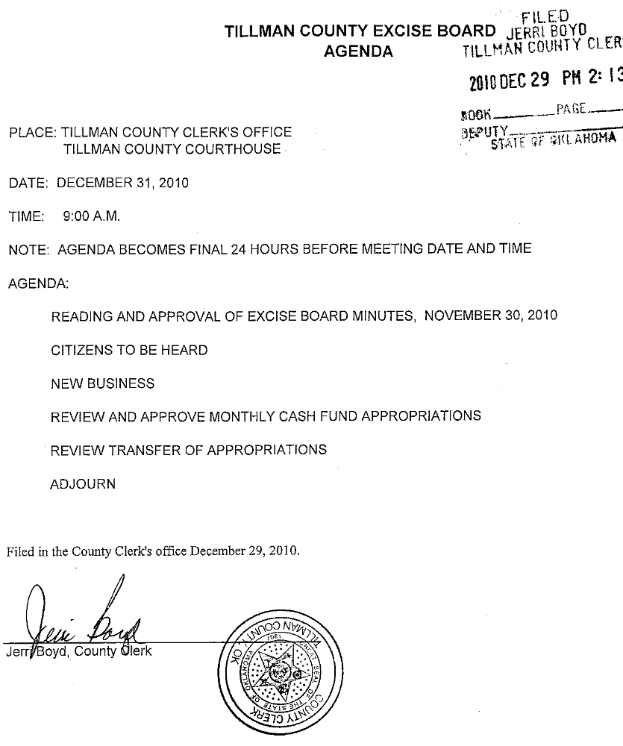 |  |  | Excise
 | REVIEW AND APPROVAL OF CASH FUND APPROPRIATIONS |  |  |  |  |  |  |  |  | 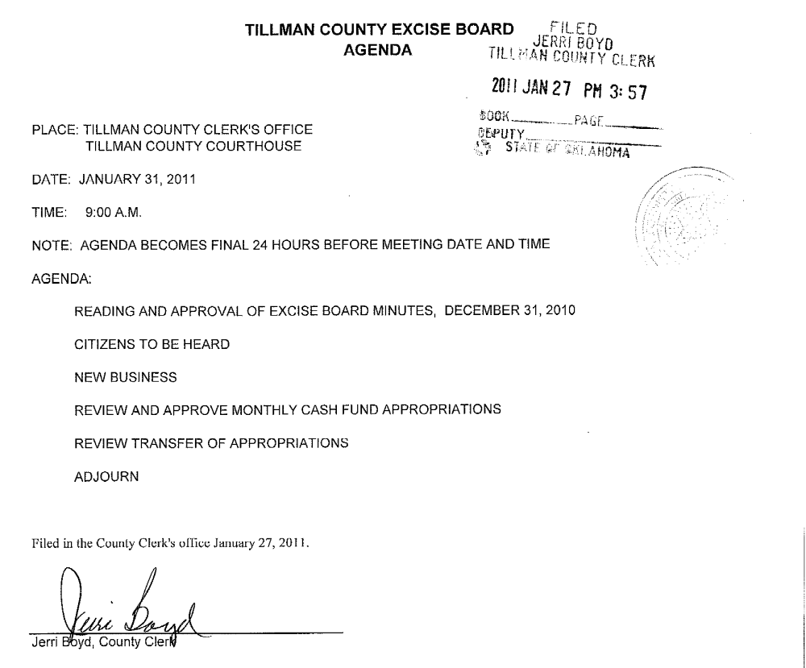
 | REVIEW AND APPROVAL OF TILLMAN COUNTY HEALTH DEPARTMENT
 | REQUEST FOR 1.57 MILL LEVY AND SURPLUS FUNDS, FY 2011
 | REVIEW OF TRANSFER OF APPROPRIATIONS FROM MAINTENANCE & OPERATION
 | ACCOUNT TO LEASE PAYMENT ACCOUNT, HIGHWAY FUND
Filed in the County Clerk's office March 29, 2010.
Jerri Boyd, County Clerk

 |  |  |  |  | SPECIAL MEETING
 |  |  |  |  | AGENDA
PLACE: TILLMAN COUNTY CLERK'S OFFICE
 | TILLMAN COUNTY COURTHOUSE
DATE: FEBRUARY 3, 2010
TIME: 9:00 A.M. | 9:00 A.M.
AGENDA:
 | READING AND APPROVAL OF EXCISE BOARD MINUTES, DECEMBER 31, 2009
 | CITIZENS TO BE HEARD
 | NEW BUSINESS
 | REVIEW AND APPROVAL OF CASH FUND APPROPRIATIONS
 | REVIEW OF TRANSFER OF APPROPRIATIONS FROM MAINTENANCE & OPERATION
 | ACCOUNT TO SALARY ACCOUNT, HEALTH DEPARTMENT
 | REVIEW OF TRANSFER OF APPROPRIATIONS FROM GENERAL FUND TO HIGHWAY
 | FUND, GENERAL LEDGER JOURNAL ENTRY
Filed in the County Clerk's office February 1, 2010.
Jerri Boyd, County Clerk

TILLMAN COUNTY EXCISE BOARD
 |  |  |  |  | AGENDA
PLACE: TILLMAN COUNTY CLERK'S OFFICE
 | TILLMAN COUNTY COURTHOUSE
DATE: JANUARY 29, 2010
TIME: 9:00 A.M. | 9:00 A.M.
AGENDA:
 | READING AND APPROVAL OF EXCISE BOARD MINUTES, DECEMBER 31, 2009
 | CITIZENS TO BE HEARD
 | NEW BUSINESS
 | REVIEW AND APPROVAL OF CASH FUND APPROPRIATIONS
 | REVIEW OF TRANSFER OF APPROPRIATIONS FROM MAINTENANCE & OPERATION
 | ACCOUNT TO SALARY ACCOUNT, HEALTH DEPARTMENT
 | REVIEW OF TRANSFER OF APPROPRIATIONS FROM GENERAL FUND TO HIGHWAY
 | FUND, GENERAL LEDGER JOURNAL ENTRY
Filed in the County Clerk's office December 28, 2009.
Jerri Boyd, County Clerk

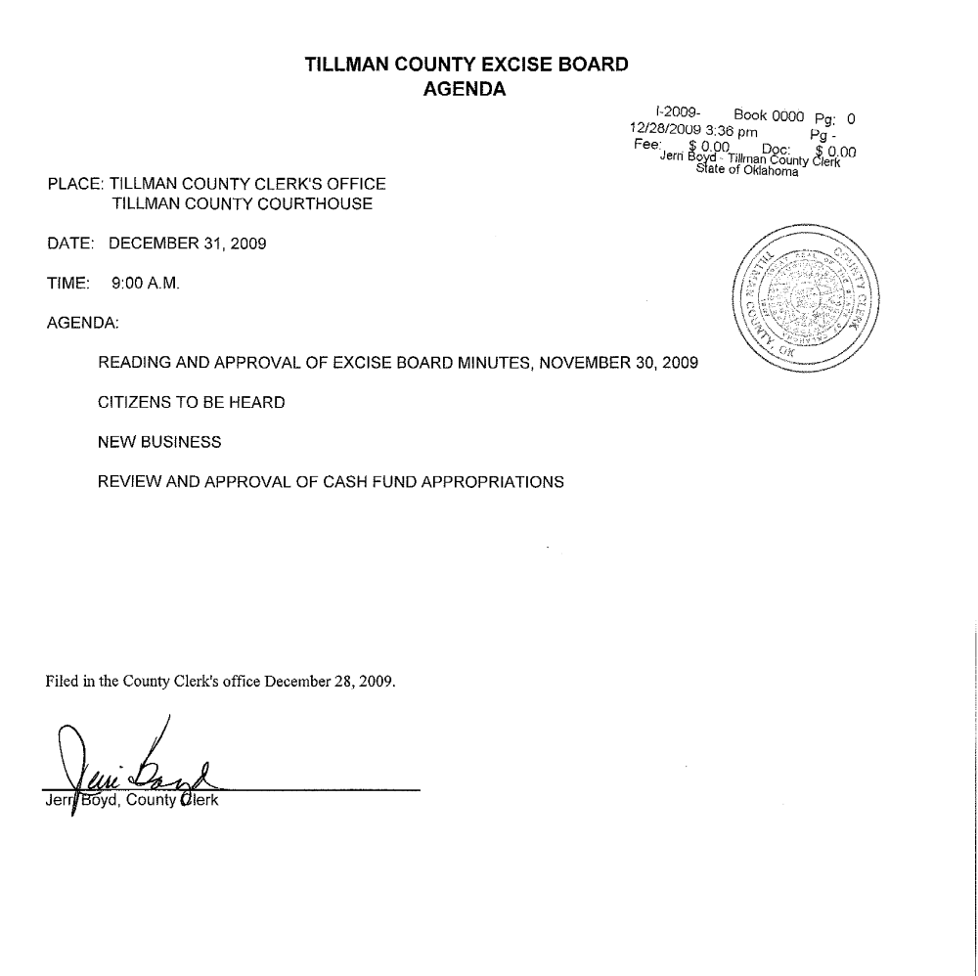
TILLMAN COUNTY EXCISE BOARD
AGENDA
PLACE: TILLMAN COUNTY CLERK'S OFFICE
TILLMAN COUNTY COURTHOUSE
DATE: SEPTEMBER 30, 2009
TIME: | 9:00 A.M.
AGENDA:
READING AND APPROVAL OF EXCISE BOARD MINUTES, AUGUST 31, 2009
CITIZENS TO BE HEARD
NEW BUSINESS
REVIEW AND APPROVAL OF CASH FUND APPROPRIATIONS
REVIEW AND APPROVAL OF TILLMAN COUNTY GENERAL BUDGET, FY '09-'10
REVIEW AND APPROVAL OF TILMAN COUNTY HEALTH DEPT BUDGET, FY '09-10
REVIEW AND APPROVAL OF TILLMAN COUNTY EMS BUDGET, FY '09-'10
REVIEW AND APPROVAL OF FREDERICK PUBLIC SCHOOLS SINKING
FUND, '09-'10
REVIEW AND APPROVAL OF GRANDFIELD PUBLIC SCHOOLS BUDGET, FY '09-'10
REVIEW AND APPROVAL OF TIPTON PUBLIC SCHOOLS BUDGET, FY '09-'10
REVIEW AND APPROVAL OF DAVIDSON PUBLIC SCHOOLS BUDGET, FY '09-'10
REVIEW AND APPROVAL OF CITY OF GRANDFIELD BUDGET, FY '09-'10
REVIEW OF TEMPORARY GENERAL LEDGER JOURNAL ENTRY TRANSFER
FROM HIGHWAY FUND TO GENERAL FUND
Filed in the County Clerk's office September 28, 2009.
Jerri Boyd, County Clerk

TILLMAN COUNTY EXCISE BOARD
 |  |  |  |  | AGENDA
TILLMAN COUNTY EXCISE BOARD
 |  |  |  |  | AGENDA
PLACE: TILLMAN COUNTY CLERK'S OFFICE
 | TILLMAN COUNTY COURTHOUSE
DATE: AUGUST 31, 2009
TIME: | 9:00 A.M.
AGENDA:
 | READING AND APPROVAL OF EXCISE BOARD MINUTES, JULY 31, 2009
 | CITIZENS TO BE HEARD
 | NEW BUSINESS
 | REVIEW AND APPROVAL OF CASH FUND APPROPRIATIONS
 | REVIEW TRANSFER OF APPROPRIATIONS, SHERIFF
 | REVIEW TRANSFER OF APPROPRIATIONS, COUNTY CLERK
Filed in the County Clerk's office August 27, 2009.
Jerri Boyd, County Clerk

PLACE: TILLMAN COUNTY CLERK'S OFFICE
 | TILLMAN COUNTY COURTHOUSE
DATE: JULY 31, 2009
TIME: | 9:00 A.M.
AGENDA:
 | READING AND APPROVAL OF EXCISE BOARD MINUTES, JUNE 30, 2009
 | CITIZENS TO BE HEARD
 | NEW BUSINESS
 | ELECTION OF TILLMAN COUNTY EXCISE BOARD CHAIRMAN, FY 2010
 | ELECTION OF TILLMAN COUNTY EXCISE BOARD VICE-CHAIRMAN, FY 2010
 | REVIEW AND APPROVAL OF APPROPRIATIONS AND CASH FUND ESTIMATE
 | OF NEEDS
 | REVIEW AND APPROVAL OF TRANSFER OF CASH ACCOUNT CARRY-OVER
 | BALANCES, FY 2009
 | REVIEW OF FINAL "ASSESSOR'S REPORT TO EXCISE BOARD" ON VALUATION
Filed in the County Clerk's office July 28, 2009.
Jerri Boyd, County Clerk

TILLMAN COUNTY EXCISE BOARD
 |  |  |  |  | AGENDA
PLACE: TILLMAN COUNTY CLERK'S OFFICE
 | TILLMAN COUNTY COURTHOUSE
DATE: JUNE 30, 2009
TIME: | 9:00 A.M.
AGENDA:
 | READING AND APPROVAL OF EXCISE BOARD MINUTES, MAY 29, 2009
 | CITIZENS TO BE HEARD
 | NEW BUSINESS
 | REVIEW AND APPROVAL OF REQUEST FOR 50% OF THE ESTIMATED AVAILABLE
 | FUNDS FOR TEMPORARY APPROPRIATIONS FOR TILLMAN COUNTY GENERAL
 | GOVERNMENT, FY 2010
 | REVIEW ESTIMATE OF NEEDS FOR ASSESSOR, COUNTY CLERK, COURT CLERK,
 | ELECTION BOARD SECRETARY, SHERIFF AND TREASURER, FY 2010
 | REVIEW OF "ASSESSOR'S REPORT TO EXCISE BOARD"
Filed in the County Clerk's office June 25, 2009.
Jerri Boyd, County Clerk

- Sheet1
TILLMAN COUNTY EXCISE BOARD
 |  |  |  |  | AGENDA
PLACE: TILLMAN COUNTY CLERK'S OFFICE
 | TILLMAN COUNTY COURTHOUSE
DATE: May 29, 2009
TIME: | 9:00 A.M.
AGENDA:
 | READING AND APPROVAL OF EXCISE BOARD MINUTES, APRIL 30, 2009
 | CITIZENS TO BE HEARD
 | NEW BUSINESS
 | REVIEW AND APPROVAL OF APPROPRIATIONS
 | REVIEW AND APPROVAL OF APPLICATION FOR TEMPORARY APPROPRIATIONS
 | FOR ISD-249, GRANDFIELD, FY 2009-2010
 | REVIEW AND APPROVAL OF APPLICATION FOR TEMPORARY APPROPRIATIONS
 | FOR ISD-8, TIPTON, FY 2009-2010
 | REVIEW AND APPROVAL OF APPLICATION FOR TEMPORARY APPROPRIATIONS
 | FOR ISD-9, DAVIDSON, FY 2009-2010
 | REVIEW OF TRANSFER OF APPROPRIATIONS, SHERIFF'S DEPARTMENT
Filed in the County Clerk's office May 27, 2009.
Jerri Boyd, County Clerk

Excise Board Agenda
TILLMAN COUNTY EXCISE BOARD
AGENDA

PLACE: TILLMAN COUNTY CLERK’S OFFICE
TILLMAN COUNTY COURTHOUSE

DATE: DECEMBER 31, 2008

TIME: 9:00 A.M.

AGENDA:

READING AND APPROVAL OF EXCISE BOARD MINUTES, NOVEMBER 25, 2008

CITIZENS TO BE HEARD

NEW BUSINESS

REVIEW AND APPROVAL OF REQUEST FOR APPROPRIATIONS

REVIEW AND APPROVAL OF TOWN OF HOLLISTER BUDGET, 2008-2009

Filed in the County Clerk’s office December 29, 2008.

__________________________________
Jerri Boyd, County Clerk

TILLMAN COUNTY EXCISE BOARD
 |  |  |  |  | AGENDA
PLACE: TILLMAN COUNTY CLERK'S OFFICE
 | TILLMAN COUNTY COURTHOUSE
DATE: JANUARY 30, 2009
TIME: 9:00 A.M. | 9:00 A.M.
AGENDA:
 | READING AND APPROVAL OF EXCISE BOARD MINUTES, DECEMBER 31, 2009
 | CITIZENS TO BE HEARD
 | NEW BUSINESS
 | REVIEW AND APPROVAL OF REQUEST FOR APPROPRIATIONS
 | REVIEW OF TRANSFER OF APPROPRIATIONS FROM HIGHWAY FUND TO
 | GENERAL FUND AS GENERAL LEDGER JOURNAL ENTRY
Filed in the County Clerk's office January 28, 2009.

DATE: MARCH 31, 2009
TIME: 9:00 A.M. | 9:00 A.M.
AGENDA:
 | READING AND APPROVAL OF EXCISE BOARD MINUTES, FEBRUARY 27, 2009
 | CITIZENS TO BE HEARD
 | NEW BUSINESS
 | REVIEW AND APPROVAL OF REQUEST FOR APPROPRIATIONS
 | REVIEW AND APPROVAL TILLMAN COUNTY HEALTH DEPARTMENT
 | REQUEST FOR 1.57 MILL LEVY AND SURPLUS FUNDS, FY 2009-2010
 | REVIEW TRANSFER OF FUNDS, HIGHWAY DEPARTMENT
 | REVIEW TRANSFER OF FUNDS, EXCISE BOARD
 | REVIEW TRANSFER OF FUNDS, VISUAL INSPECTION
 | REVIEW OUTCOME OF COMPLIANCE MANDATES
Filed in the County Clerk's office March 26, 2009.
Jerri Boyd, County Clerk

TILLMAN COUNTY EXCISE BOARD
 |  |  |  |  | AGENDA
PLACE: TILLMAN COUNTY CLERK'S OFFICE
 | TILLMAN COUNTY COURTHOUSE
DATE: APRIL 30, 2009
TIME: | 9:00 A.M.
AGENDA:
 | READING AND APPROVAL OF EXCISE BOARD MINUTES, MARCH 31, 2009
 | CITIZENS TO BE HEARD
 | NEW BUSINESS
 | REVIEW AND APPROVAL OF REQUEST FOR APPROPRIATIONS
Filed in the County Clerk's office April 28, 2009.
Jerri Boyd, County Clerk

